**Name:** Atif Ansari

**Roll no:** 04

**Class:** D15B

**Experiment 10**

**Aim:** To perform Port, Service monitoring, Windows/Linux server monitoring using Nagios.

**Steps:**

Prerequisites: AWS Free Tier, Nagios Server running on Amazon Linux Machine.

1. To Confirm that Nagios is running **on the server side**, run this *sudo systemctl status nagios* on the “NAGIOS HOST”.

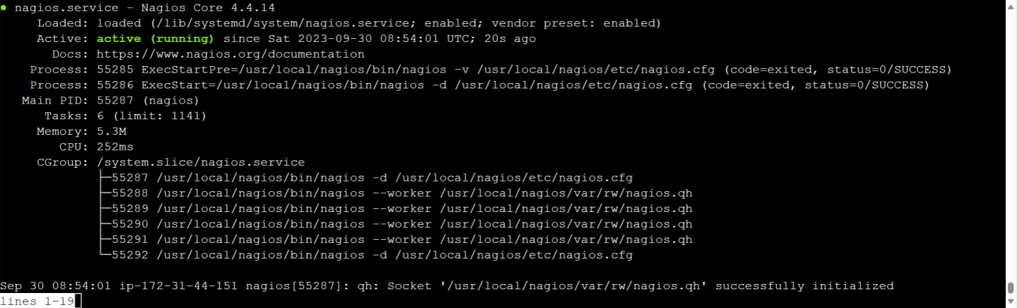

You can proceed if you get this message.

1. Before we begin,

To monitor a Linux machine, create an Ubuntu 20.04 server EC2 Instance in AWS.

Provide it with the same security group as the Nagios Host and name it ‘linux-client’ alongside the host.

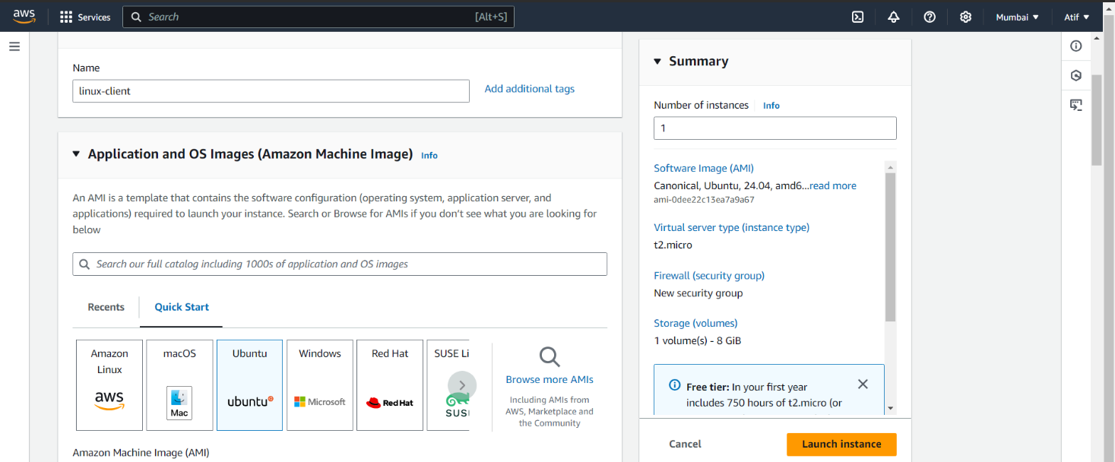

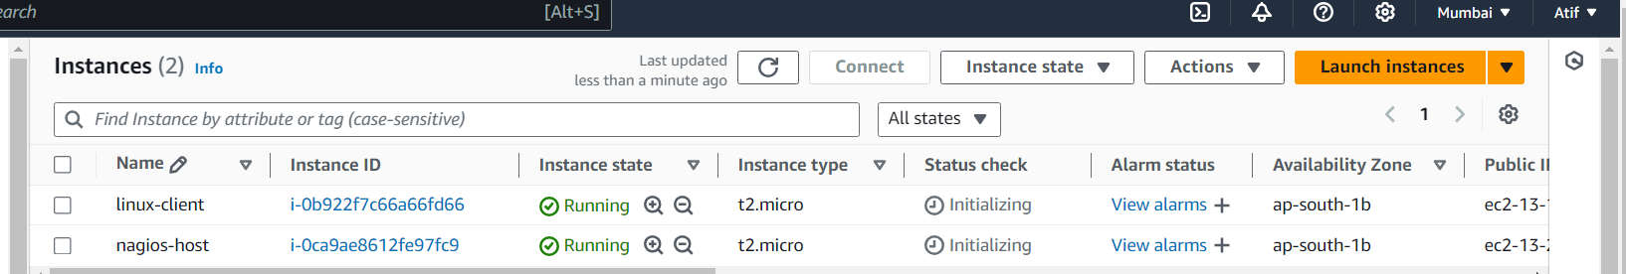

**For now, leave this machine as is, and go back to your nagios HOST machine**.

**Step 3:** On client side make a package index update and install gcc, nagios-nrpe-server and the plugins.

sudo apt update -y

sudo apt install gcc -y

sudo apt install -y nagios-nrpe-server nagios-plugins

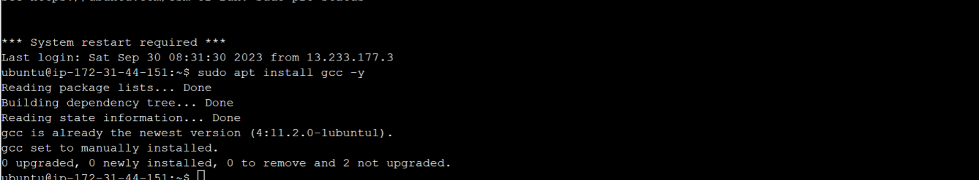

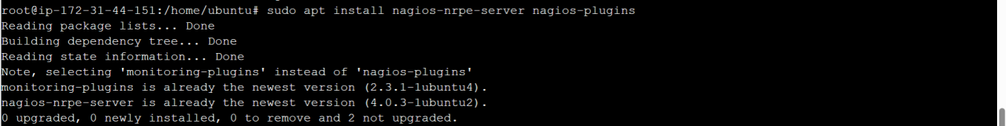

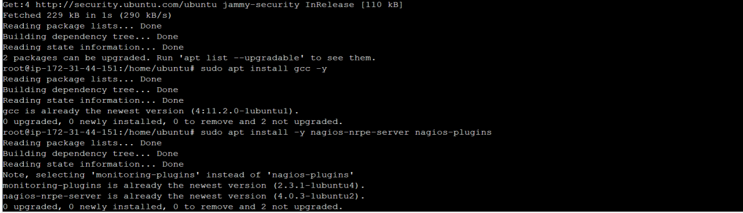

**Step 4:** Open nrpe.cfg file to make changes.

sudo nano /etc/nagios/nrpe.cfg

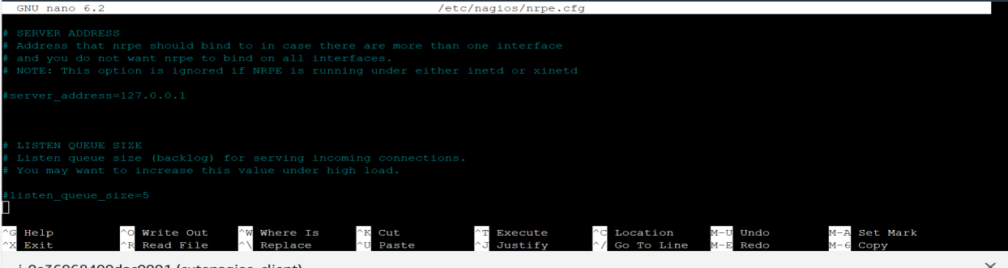

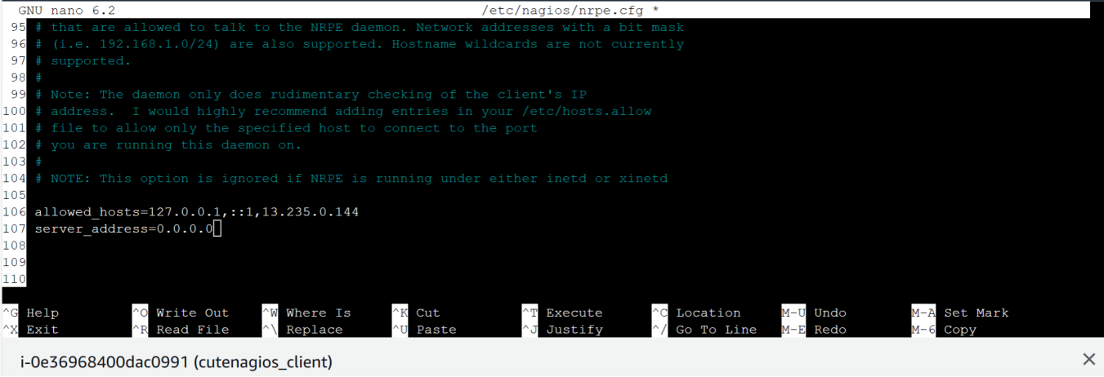

**Step 5:** Restart the NRPE server

sudo systemctl restart nagios-nrpe-server

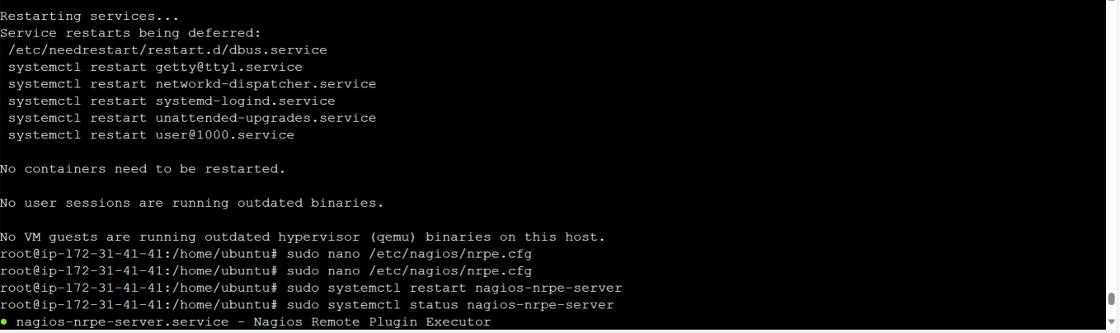

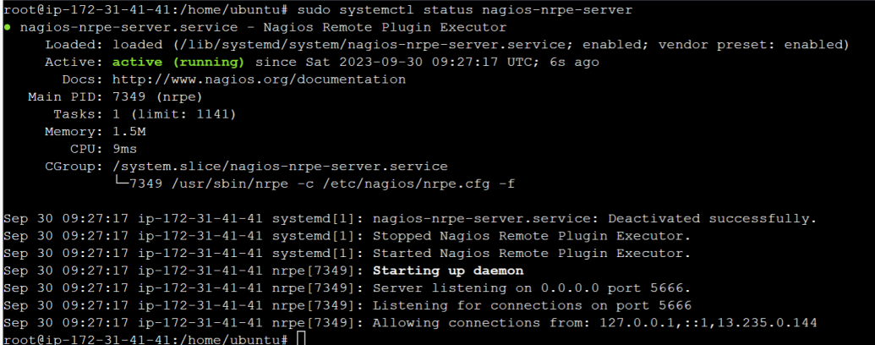

**Step 6:** On the server run this command

ps -ef | grep nagios

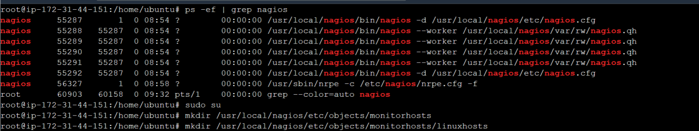

**Step 7:** Become a root user and create 2 folders 1.sudo su 2.mkdir /usr/local/nagios/etc/objects/monitorhosts 3.mkdir /usr/local/nagios/etc/objects/monitorhosts/linuxhosts Copy the sample localhost.cfg file to linuxhost folder 4.cp /usr/local/nagios/etc/objects/localhost.cfg /usr/local/nagios/etc/objects/monitorhosts/linuxhosts/linuxserver.cfg

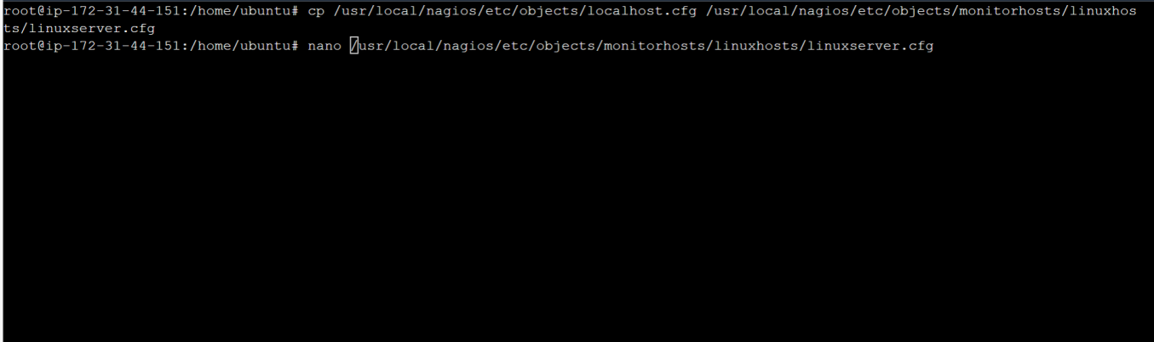

**Step 8:** Open linuxserver.cfg using nano and make the following changes

nano /usr/local/nagios/etc/objects/monitorhosts/linuxhosts/linuxserver.cfg Change the hostname to linux server (EVERYWHERE ON THE FILE) Change address to the public IP address of your LINUX CLIENT.

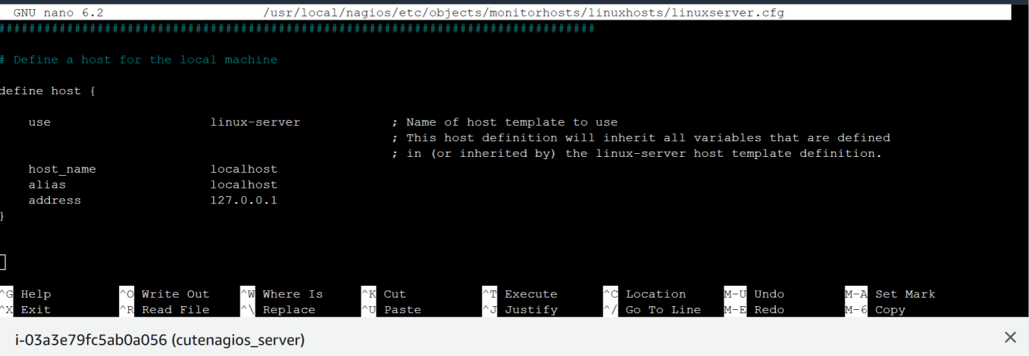

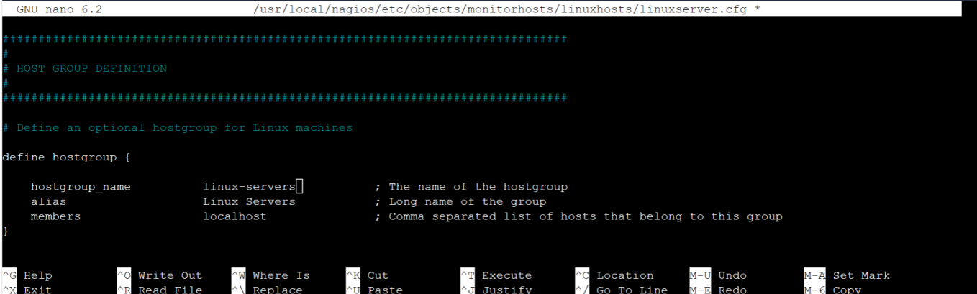

Change hostgroup_name under hostgroup to linux-servers1

**Step 9:** Open the Nagios Config file and add the following line nano /usr/local/nagios/etc/nagios.cfg Add this line cfg_dir=/usr/local/nagios/etc/objects/monitorhosts/

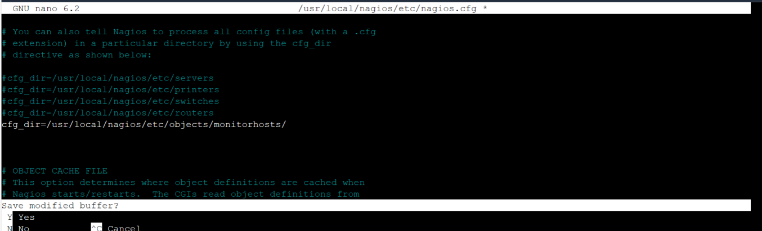

**Step 10:** Verify the configuration files.

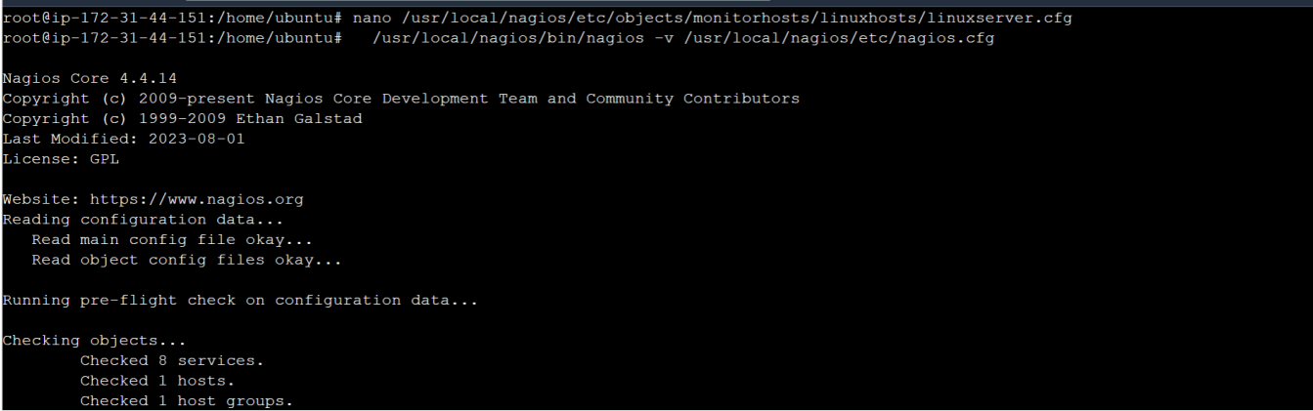

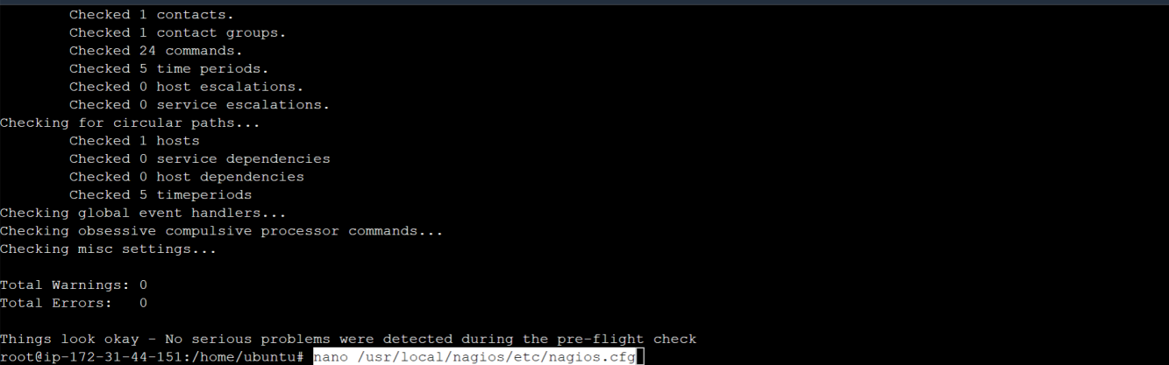

**Step 11:** Restart the nagios service service nagios restart

Sudo systemctl status nagios

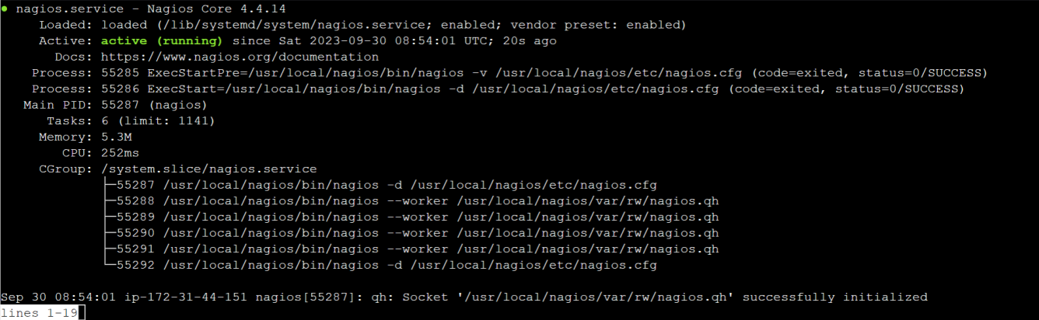

**Step 12:** Now, check your nagios dashboard and you’ll see a new host being added.

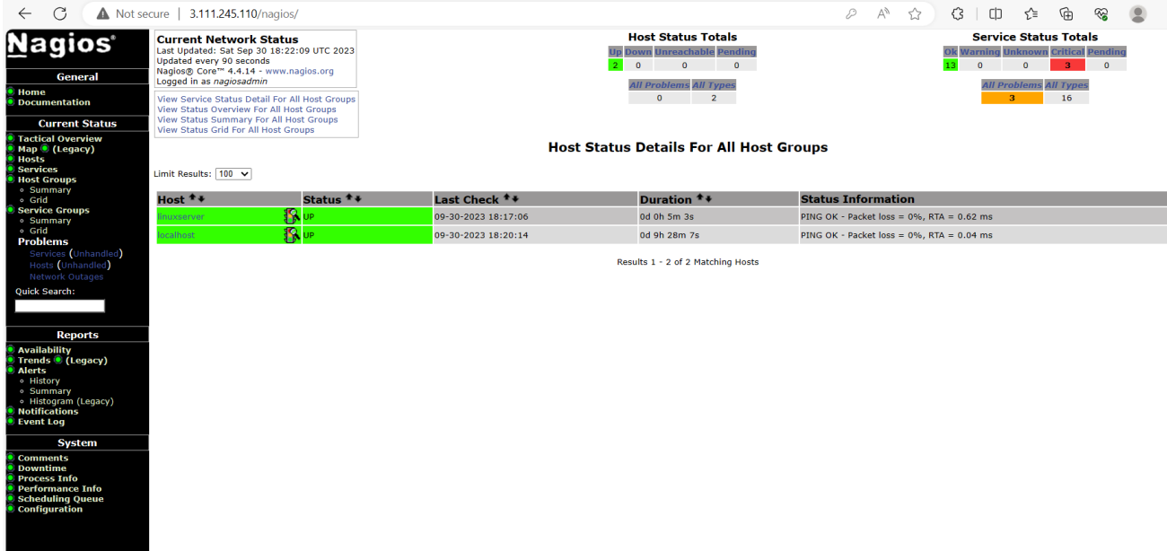

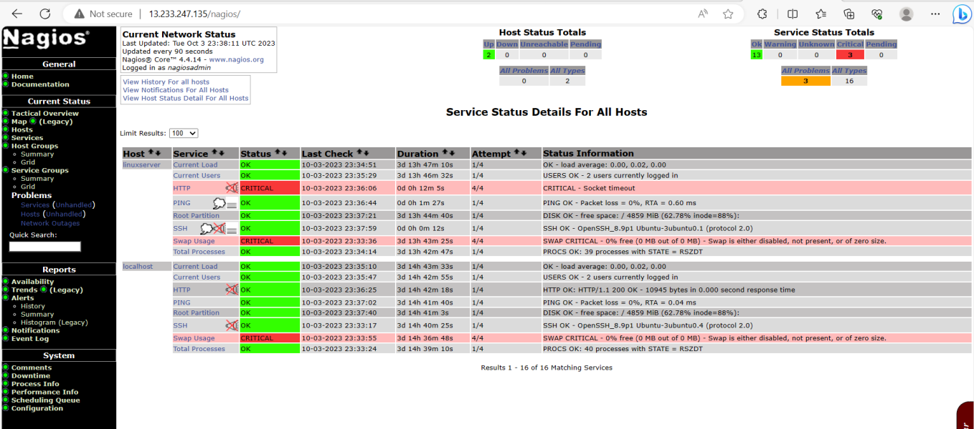

As you can see, we have our linuxserver up and running. It is showing critical status on HTTP due to permission errors and swap because there is no partition created.

**In this case, we have monitored - Servers: 1 linux server**

**Services: swap**

**Ports: 22, 80 (ssh, http)**

**Processes: User status, Current load, total processes, root partition, etc.**

**Recommended Cleanup**

* Terminate both of your EC-2 instances to avoid charges.
* Delete the security group if you created a new one (it won’t affect your bill, you may avoid it)

**Conclusion:**

Thus, we learned about service monitoring using Nagios and successfully monitored a Linux Server and monitored its different ports and services using Nagios and NRPE.